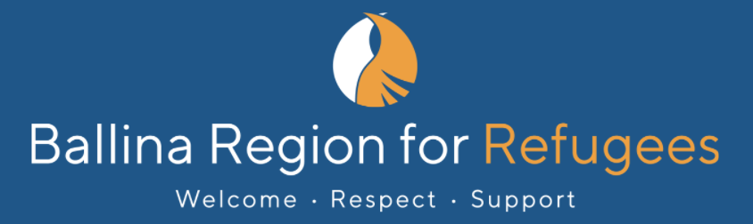

The 2022 BR4R Seeking Asylum Poetry Prize
A Turning Point
Entry Form

Entries close on Sunday 14th August, 2022

Before you complete this form, please read the information sheet.
You can enter up to 3 on this one form.

Send your email to poetryprize@br4r.org.au.
Your name
Your Australian postal address
Contact email address
I declare that this is my own work |  | Yes ☐ No ☐
I consent to my poem or poems being published by Ballina Region for Refugees and the journal Social Alternatives |  | Yes ☐ No ☐
I am or have been a refugee or asylum seeker |  | Yes ☐ No ☐

Copy and paste your poem or poems here.

Poem 1: Insert title here

Paste poem here

Poem 2: Insert title here

Paste poem here

Poem 3: Insert title here

Paste poem here

