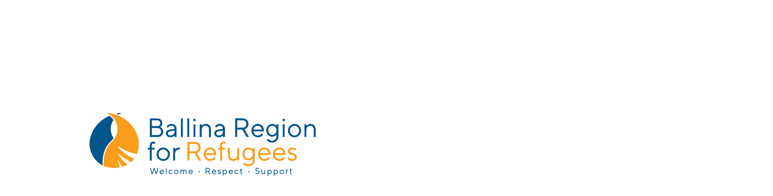

**Ballina Region for Refugees (BR4R) Poetry Prize 2019**

Proudly supported by

[Sunday 16 June, 2019](x-apple-data-detectors://1) – [Sunday 18 August, 2019](x-apple-data-detectors://2)

**Guidelines for Entry and Terms & Conditions**

By entering the *Seeking Asylum Poetry Competition* to win a $1000 first-place prize, conducted by Ballina Region for Refugees Ballina NSW, 2478, ABN: 64 683 380 227 you agree to the following terms and conditions:

1. **Who Can Enter?**
   1. Entry is free and open to anyone residing in Australia.
   2. By entering this competition, you agree that if you are under 18 years of age, you have your parent’s or legal guardian’s consent to enter this competition.
2. **How to Enter?**
   1. The competition commences [at 9am Sunday 16 June, 2019](x-apple-data-detectors://1) and closes [at 11pm Sunday 18 August, 2019](x-apple-data-detectors://2) AEST.
   2. Entries must be a single poem of no more than 50 lines.
   3. Entries must be written mostly in English (some untranslated words and phrases are acceptable: up to 10% of the total word count). A glossary of untranslated words should be provided for the judges.
   4. The text should be presented with 1.5 line spacing and in 12 pt plain font. Pages should be numbered.
   5. The author’s name must not appear in the document or in the name of the digital file. The file name should include only the title of the poem. The author’s name and contact information should appear only on the entry form.
   6. Multiple entries are permitted, but each poem must be accompanied by a separate entry form. There is only one prize of $1000.
   7. Entries must be original works written by an individual author.
   8. Entries should not be on offer to other publications or prizes for the duration of the competition.
   9. Previously published, shortlisted, or prize-winning poems will not be accepted.
   10. All entries must be accompanied by an entry form with all required fields completed.
   11. Email your submission along with the entry form in two separate Word documents attached to the same email to [poetryprize@br4r.org.au](mailto:poetryprize@br4r.org.au) .
3. **Prize details**
   1. The winning entry will receive a $1000.00 prize, direct deposited to their bank account and will be published in a forthcoming issue of *Social Alternatives*.
   2. A limited number of runners up may also be selected for publication in *Social Alternatives*. No cash prize will be awarded to runners up.
   3. In the event of unforeseen circumstances, *Social Alternatives* reserves the right to not publish the winner or any runners-up.
4. **Judging process** 
   1. The winning entry will be chosen by a panel of three judges.
   2. The judging is completely anonymous.
   3. The judges are Saba Vasefi, Manal Younus, and Ella Jeffery. In the event of unforeseen circumstances, BR4R reserves the right to change the judging panel.
   4. BR4R reserves the right not to award a prize if the judges so recommend.
   5. The winner will be notified directly, either by phone or email, before September 22, 2019.
   6. The judges’ decision is final (unless unclaimed), and no correspondence will be entered into about the judgements or the judging process.
   7. BR4R reserves the right to select an alternative winner in the event the winner is unable to satisfy these terms and conditions, forfeits, or does not claim the prize.
   8. If the prize is unclaimed within 14 days, the prize will be awarded to the judges’ next preference. The initial selection will be notified by email that they are no longer eligible for the prize due to the lapse of 14 days.
   9. If you win the competition and are under 18 years of age, BR4R may elect to award the prize to your parent or legal guardian.
5. **Limitation of Liability**
   1. If for any reason this competition is not capable of running as planned because of infection by computer virus, bugs, tampering, unauthorised intervention, technical failures or any other causes beyond the control of BR4R which corrupts or affects the administration, security, fairness, integrity or proper conduct of this competition, BR4R reserves the right in their sole discretion to cancel, terminate, modify or suspend the competition subject to any written directions under applicable legislation. BR4R also reserves the right to disqualify any individual who they have reason to believe has breached any of these conditions, or engaged in any unlawful or other improper misconduct calculated to jeopardise the fair and proper conduct of the competition.
   2. BR4R accepts no responsibility and shall not be held legally liable or responsible for any accident, loss, injury or damage to any individual or property whether direct or indirect, whether in contract, tort or negligence or otherwise arising out of or in connection with the competition or the prize either during or after the competition.
6. **Privacy**
   1. Personal Information provided to BR4R is for the purpose of conducting the competition and notifying the winner. Personal information collected will be kept strictly confidential and will not be sold, reused, rented, loaned or otherwise disclosed to a third party otherwise than in accordance with these terms and conditions.